Lesson 4 Quiz

4 questions

Correct

1 / 1 points

1. Suppose one needs to frequent patterns at two different levels, with mini-support (minsup) of 5% (higher level) and 3% (lower level), respectively. If *using shared multi-level mining*, which mini-support (minsup) threshold should be used to generate candidate patterns for the higher level?

3%

8%

5%

1%

1  
point

2. A store had 100,000 total transactions in Q4 2014. 10,000 transactions contained eggs, while 5,000 contained bacon. 2000 transactions contained both eggs and bacon. Which of the following choices for the value of ε is the smallest such that {eggs, bacon} is considered a negative pattern under the null-invariant definition?

0.1

0.8

0.01

A value for ε such that {eggs, bacon} is a negative pattern under the null-invariant definition does not exist.

0.5

1  
point

3. Below is a table of transactions. According to the introduced pattern distance measure, what is the distance between pattern "abc" and pattern "abd"?

|  |  |
| --- | --- |
| Transaction | Item set |
| T1 | abcde |
| T2 | abefg |
| T3 | abcdef |
| T4 | abcdf |
| T5 | abcdeg |

0.5

0

0.2

0.333

1  
point

4. 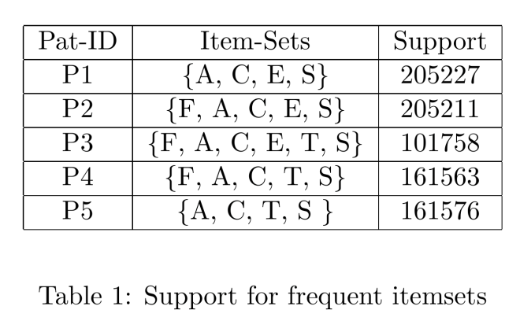

Given the itemsets in Table 1 and a cluster quality measure δ = 0.001, what could be a set of representative patterns that covers all itemsets in Table 1?

*Hint*: The pattern with the least support is {F, A, C, E, T, S}. Consider which pattern in the table may δ-cover the pattern {F, A, C, E, T, S}.

{{F, A, C, E, S}, {F, A, C, E, T, S}, {F, A, C, T, S}}

{{F, A, C, E, T, S}}

{{F, A, C, E, S}, {A, C, E, S}}

{{F, A, C, E, S}, {F, A, C, T, S}}

{{A, C, E, S}, {A, C, T, S}}

Correct

1 / 1 points

5. A store had 100,000 total transactions in Q4 2014. 10,000 transactions contained beer, while 5,000 contained frying pans. 600 transactions contained both beer and frying pans. Which of the following is true?

{beer, frying pans} is a negative pattern under the support-based definition of negatively correlated patterns.

For ε = 0.1, {beer, frying pans} is a negative pattern under the null-invariant definition of negatively correlated patterns.

More information is needed to determine if {beer, frying pans} is a negative pattern.

There does not exist a value for ε such that {beer, frying pans} is a negative pattern by the null-invariant definition of negative patterns.

Correct

1 / 1 points

6. 

Given the itemsets in Table 1, which of the following patterns are in the δ-cluster containing the pattern {A, C, E, S} for δ = 0.0001?

*Hint*: Consider two patterns *P1* and *P2* such that O(*P1*) ⊆ O(*P2*), where O(*Pi*) is the corresponding itemset of pattern *Pi* . Take a second to convince yourself that the following is true:

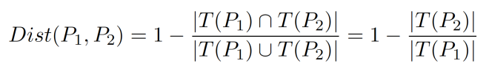

{F, A, C, E, S}

{F, A, C, T, S}

{A, C, T, S}

{F, A, C, E, T, S}

1  
point

4. 

Consider two patterns *P1* and *P2* such that O(*P1*) ⊆ O(*P2*), where O(*Pi*) is the corresponding itemset of pattern *Pi*. Take a second to convince yourself that the following is true:



Which of the following patterns in Table 1 is δ-covered by {F, A, C, E, T, S} for δ=0.4? Select all that apply.

{F, A, C, T, S}

{A, C, T, S}

{F, A, C, E, S}

{A, C, E, S}

Submit Quiz